Amazon EC2 AMI Backup Using Lambda Functions
Pradeep Kumar Mugithe
Computer Information Technology
Purude School of Engineering and Technology
IUPUI, Indianapolis.
pmugithe@iu.edu

Abstract— The main objective of this project is to manage the EC2 AMI backup for EC2 Instances using AWS lambda functions in Python. Creating a backup for each EC2 Instances and deleting the EC2 AMIs which are older than 30 days or more. Using Python and AWS Lambda Functions, the whole process is going to be self-triggered. When deletion is happened, using AWS SNS, a notification will be sent to registered email address. This project uses technologies like AWS EC2, AWS SNS, AWS CloudWatch and the programming language that will be used in this project is Python.
Keywords—AWS EC2, AWS Lambda, AWS CloudWatch, AWS SNS, Python, Deletion, Notification.

Introduction
The significance of data backup and recovery in ensuring system availability and security. One of the most well-known cloud computing services is Amazon Elastic Compute Cloud (EC2), which offers a scalable and adaptable platform for hosting different kinds of databases and applications. To guard against data loss or system failures, it is essential to maintain a backup of the Amazon Machine Images (AMIs) as part of managing EC2 instances.
A frequent backup of Amazon Machine Images (AMIs) is needed for the widely utilized Amazon Elastic Compute Cloud (EC2) service in order to maintain system continuity and stability. Amazon Machine Images (AMIs) backup creation is a laborious, error-prone operation that, if done incorrectly, may result in data loss or system disruption.
To solve this problem, we proposed a system that uses AWS Lambda functions to automatically backup AMIs, register new AMIs, and deregister any older AMIs that have reached their retention limit. By automating the process, backups may be produced often and consistently while also saving time.
This system is implemented by developing a Lambda function that will be called by a CloudWatch Event rule at predetermined intervals. In addition to determining which instances need to be backed up, the Lambda function will also create EBS volume snapshots, register new AMIs based on the snapshots, and deregister older AMIs that have exceeded their retention period.
The remaining sections of this paper are structured as follows: Section II: Implementation, this section will describe the technical aspects regarding how the AWS Lambda function was developed to automate the backup procedure for EC2 AMIs. The results of our testing and analysis, as well as the efficiency of the automatic backup procedure, will be presented in Section III: Evaluation. Finally, Section IV: Conclusion will emphasize the practical outcomes of using AWS Lambda functions for automating the backup process of EC2 AMIs, limitations and future work.

IMPLEMENTATION
The technical specifics of implementing the Amazon EC2 AMI backup system utilizing AWS Lambda functions will be thoroughly reviewed in this section. There are five stages of implementation, each of which is very important to automating the backup process and ensuring that backups are created regularly and consistently.
The five stages of implementing this project are as follows:
- Identification of EC2 Instances
- Creating EBS volume snapshots
- Deleting Old AMIs
- Scheduling Lambda functions using Cloud Watch
- Sending an Email to the registered user

1. Identification of EC2 Instances.
Finding the EC2 instances that require backup is the first step in the implementation procedure. This can be achieved by using the tags associated with EC2. Using this feature, it is possible to configure the created Lambda function to retrieve this data and filter the instances according to a variety of parameters, such as state, location, or tags. Once the Instances have been identified, the second step is to create EBS volume snapshots.

2. Creating EBS Volume snapshots.
The next step is to create EBS volume snapshots after the instances that need to be backed up have been identified. Lambda function creates a backup of identified instances in EBS volume and then the backed-up images are stored in S3 and tagged with the key backup and value true. The reason behind the tagging is to make sure that only the backups are removed or deregistered during the deletion phase. The instance ID and the current timestamp are combined to name the backup files (AMIs).
It is vital to ensure that the snapshot matches the instance's state at the time of the backup because differences could lead to data loss or corruption.

3. Deregistering Old AMIs.
It is very important to delete older AMIs that have exceeded their retention time as fresh AMIs are registered. To keep the list of AMIs manageable and avoiding unpredictable costs, it is crucial to make sure that outdated AMIs are correctly eliminated.
Using the Lambda function that we created when the lambda function is triggered by the CloudWatch triggers, it filters out instances and sees if they were backed up or not, and if the instances have a key backup enabled and value to true, it then checks for retention time. If the retention time is greater than 30 days, lambda function deregisters the instance using image ID. Below is the lambda function written in python language.
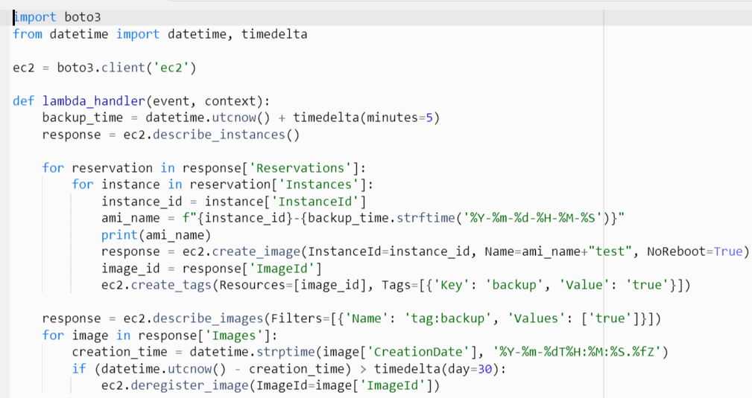
Figure 1: Lambda Function

4. Scheduling Lambda functions using Cloud Watch.
For the above lambda function to perform the required tasks, it must have sufficient permission to do so. For this we created an IAM role and granted it to the lambda function created above. We then created a policy with the required permissions and attached it to the IAM role previously created. As show in fig below, some of the permissions in the policy are list instances, describe instance, create image, and delete snapshot.

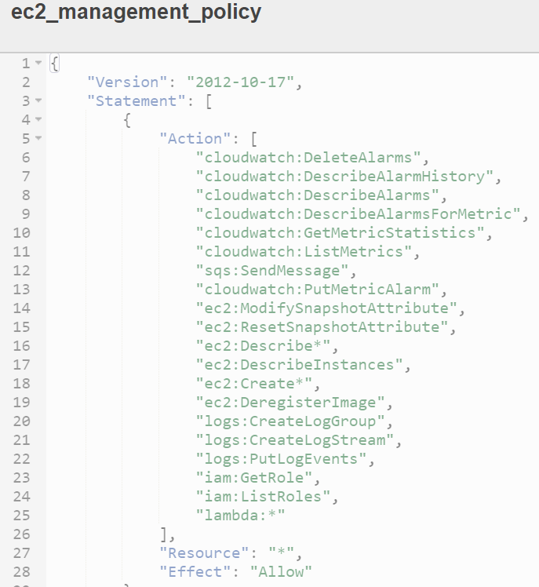
Figure 2: IAM Policy
For the above function to work properly, it must be invoked first. This can be achieved by using the CloudWatch trigger which we scheduled to run daily. Once the CloudWatch triggered the lambda function, it performs as outlined so far.

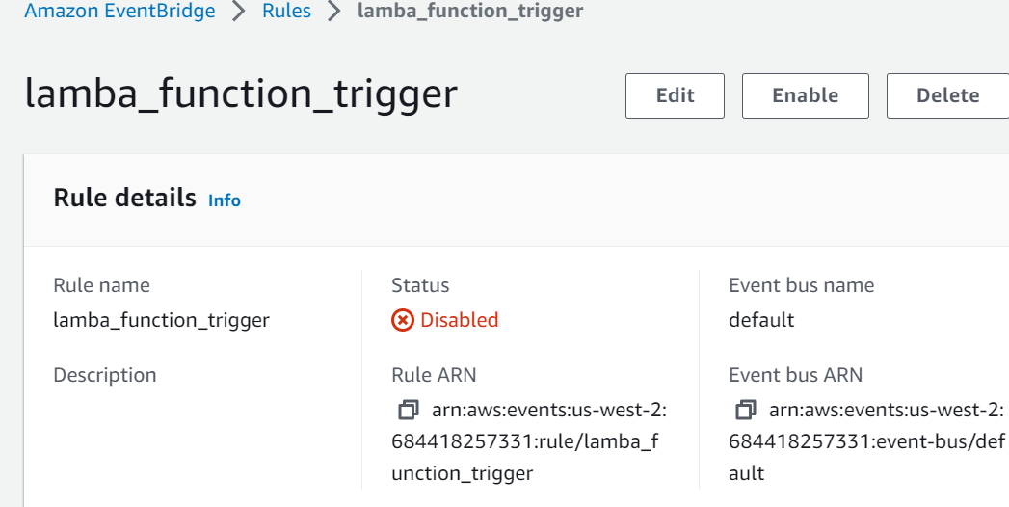
Figure 3: CloudWatch Trigger

5. Sending an Email Notification.
Finally, it is important to monitor the backup process and log the events so that potential problems can be found and fixed before they arise. Utilizing AWS CloudWatch is one way to accomplish the monitoring step. Created a CloudWatch rule to monitor the creation and deletion of snapshot activities, and then created a topic and subscription.
When the subscription was created, we included the necessary email(s) for the users who needed to be informed or notified when snapshots were produced or deleted. We then set the target of the CloudWatch rule above as the SNS topic created.
Below is the Topic we created for the purpose of notifications.

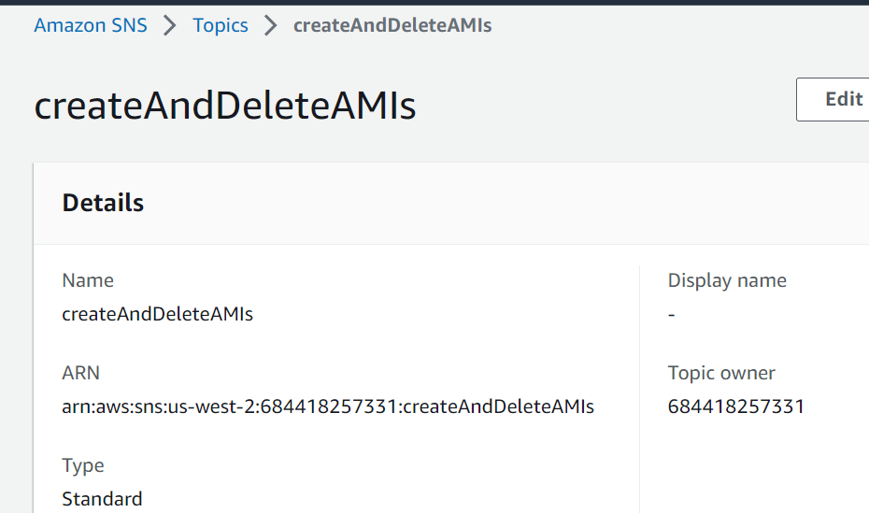
Figure 4: Topic for SNS Notification

Below are the few rules which are created for the purposes of triggering and monitoring.

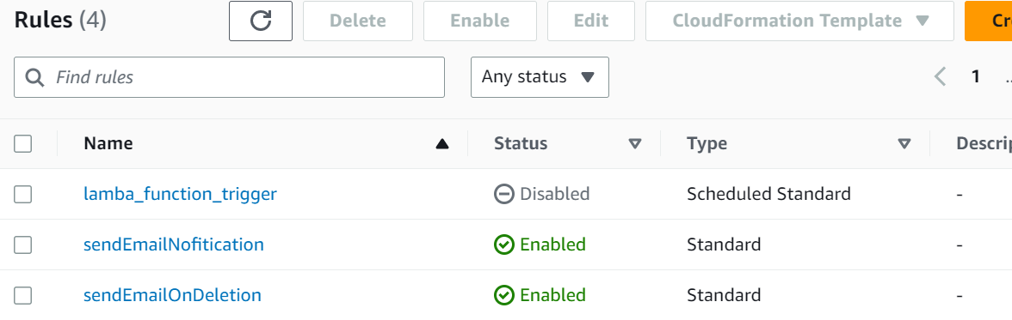
Figure 5: CloudWatch Rules
The CloudWatch rule routes any creation or deletion of a snapshot event to the target (the SNS topic mentioned above) and alerts the subscribers about the activity.

EVALUATION
The outcomes of the project “Amazon EC2 AMI Backup Using Lambda Functions” are shown in the evaluation section of this report. This section talks about how many of the objectives in the proposal were accomplished and how the tested system functioned. Using a test environment, the evaluation simulates real-world events such as the backup procedure, the registration of new AMIs, and the deregistration of existing and backed up AMIs.

Using AWS Lambda functions, we were able to develop an automated backup procedure for Amazon EC2 AMIs. The project's objective of automating the backup procedure to save time and guarantee that reliable backups were regularly produced was accomplished.

The created Lambda function was put to the test manually and using pre-scheduled CloudWatch events in order to assess the project. We checked that the function registered new AMIs, created EBS volume snapshots, identified the instances to backup, and deregistered older AMIs using tag key backup and value true that had reached the retention limit and sent notification to the registered user or admin email. We also verified that the function worked as intended and finished all necessary activities in the allotted period.
Below is the image that shows the EBS Volume snapshots that have been created for the Instances.
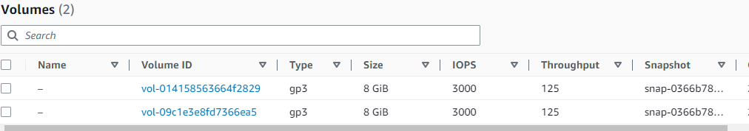
Figure 6:EBS Volume Snapshots

We have included a few screenshots of the AWS Lambda console that display the function's code, configuration, execution history and results of notifications being sent to the user to illustrate the project's functionality.

Below is the image that shows the CloudWatch trigger.

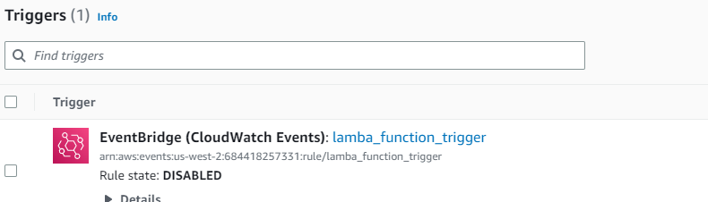
Figure 7:CloudWatch Trigger

Additionally, we have screenshots of the EC2 instances that display the backups and related AMIs. These screenshots offer concrete proof of the project's effective setup and working.

Below figure shows the AMI has been created for the Test 1 Instances in list of EC2 Instances.

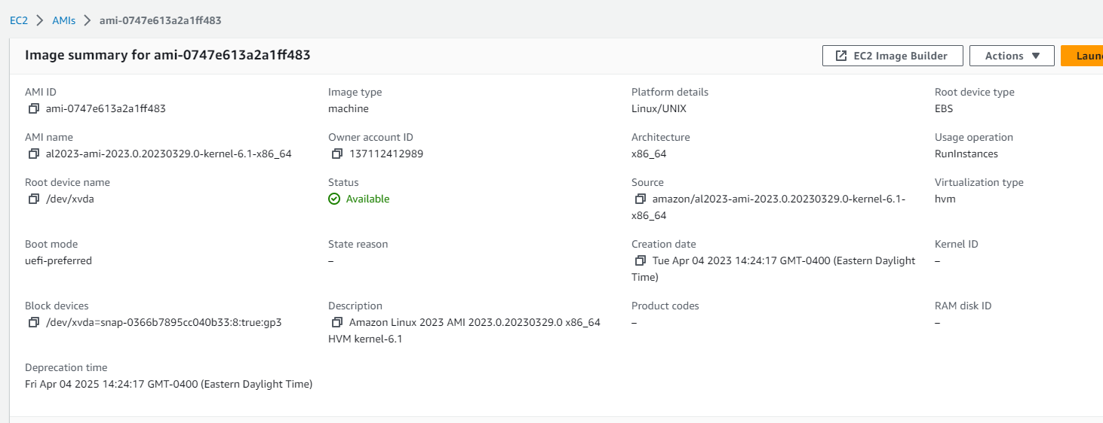
Figure 8: Created AMI

Below are the images that show the notifications being to the registered user email address for the creation and deletion of AMIS.
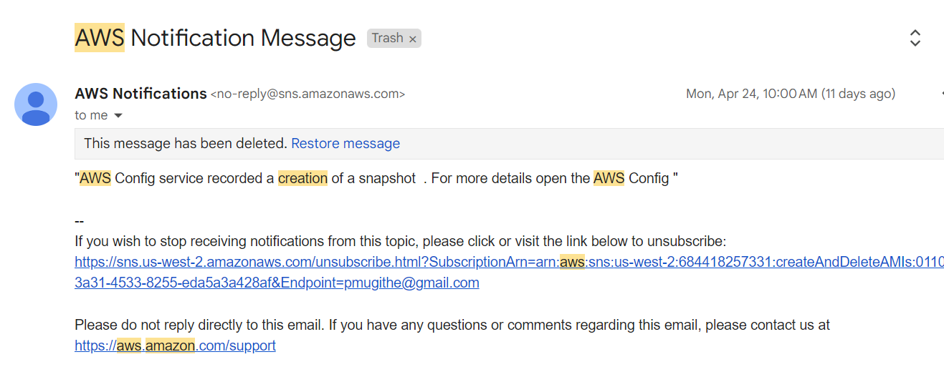
Figure 9: Notification of Snapshot Creation

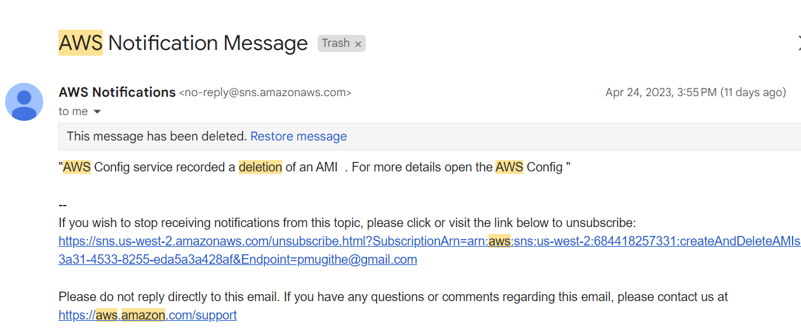
Figure 10: Notification of Snapshot Deletion

Overall, the project has shown that using Lambda functions to automate the backup of EC2 AMIs may be a dependable and effective way to manage cloud instances. The project can be further altered to satisfy certain backup needs, such as extending the retention duration or giving the instances more tags. Implementing the project has demonstrated how AWS Lambda can be used to automate repetitive operations and increase operational effectiveness.

IV:CONCLUSION
In conclusion, automating the backup process and lowering the risk of data loss or system disruptions were both successfully accomplished by the implementation of the EC2 AMI backup using Lambda functions. AMI backups can be created and deleted using the Lambda function depending on a specified retention period of 30 days. The Lambda function is executed everyday thanks to the usage of CloudWatch triggers, ensuring reliable and constant backup procedures.
Along with improving transparency and communication within the system, the integration of SNS for email alerts has given users a method to stay informed about the creation and deletion of snapshots.
However, there are drawbacks to this solution, including the fact that the retention duration is set at 30 days and that customizing backup schedules is not an option. It is advised to give additional flexibility to the system and allow for personalized backup schedules based on the demands of the users in order to solve these restrictions. Overall, the management of EC2 AMIs in the AWS environment is made efficient and effective by this design.

RECOMMENDATION
According to the project's evaluation and the constraints that were discovered, there are a few areas that can be improved to raise the system's effectiveness, scalability, and usability. These suggestions are meant to solve the discovered shortcomings and improve the system's overall effectiveness. The most important suggestions that can be put into practice to improve the system's operation and efficiency are listed in the section that follows.
1.Support for many clouds: Adding support for additional clouds, such Microsoft Azure, or Google Cloud Platform, can help the project be more adaptable.
2.Use of AWS Step processes: To backup instances with big volumes or longer retention periods, AWS Step Functions can be used to backup process and coordinate many Lambda processes.
3.Integration with Other Services: The project's functionality can be improved, and it can offer more powerful data protection and disaster recovery capabilities by integrating with other AWS services like AWS Backup.

References
- AWS Automatic AMI creation
https://towardsaws.com/aws-automatic-ami-creation-168aa2056392
- AWS automated backups of AWS EC2 instances using AWS lambda. https://gist.github.com/davebarnwell/dd2c82f61650f209e5ecb8e505f4774c
- Amazon AWS EBS Backup via Lambda and CloudWatch https://asmed.com/lambda-backup-ec2-instance/
- Automate EC2 AMI Backup Using Lambda Function https://www.devopsage.com/automate-ec2-ami-backup-using-lambda-functionpython-2-7-runtime/
- Automated Backup of AWS Linux EC2 machines using Lambda functions
https://www.linkedin.com/pulse/automated-backup-aws-linux-ec2-machines-usinglambda-functions-jain/
- How to Automate AMI Backups and Cleanups, using AWS Lambda (Serverless), with EC2 Tags
https://www.reddit.com/r/aws/comments/6z91xt/how_to_automate_ami_backups_and_cleanups_using/
- Amazon EventBridge is the preferred way to manage your events.
https://docs.aws.amazon.com/AmazonCloudWatch/latest/events/WhatIsCloudWatchEvents.html

